Lab- 3 Packet Tracing

Task-1: Use Cisco Packet Tracer tool to design and configure a small network.
Create a network topology with routers, switches, and end devices.
- Assign IP addresses and configure routing protocols (e.g., RIP, OSPF).
- There are 2 Routers with IP assigned as:
Router0- 192.168.10.1 & Router1- 192.168.20.1
- There are 2 switches which are connected with routers and further they are connected with the consequently PCs.
- There are 4 PC with IP assigned as: PC1- 192.168.10.10, PC2-192.168.10.11, PC3- 192.168.20.10, PC4- 192.168.20.11
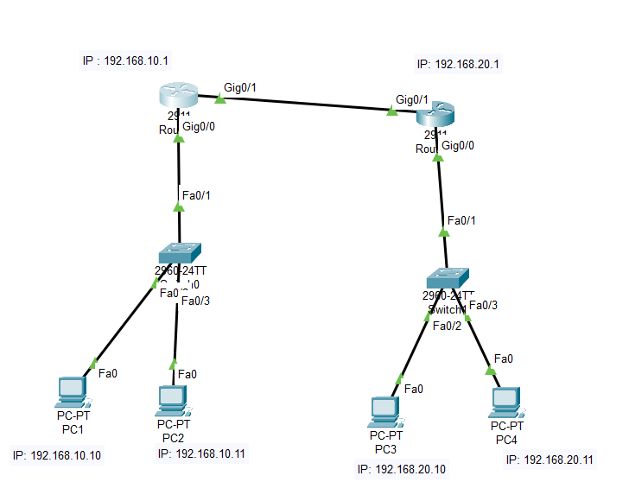

- Simulate traffic between devices and analyze packet flow.
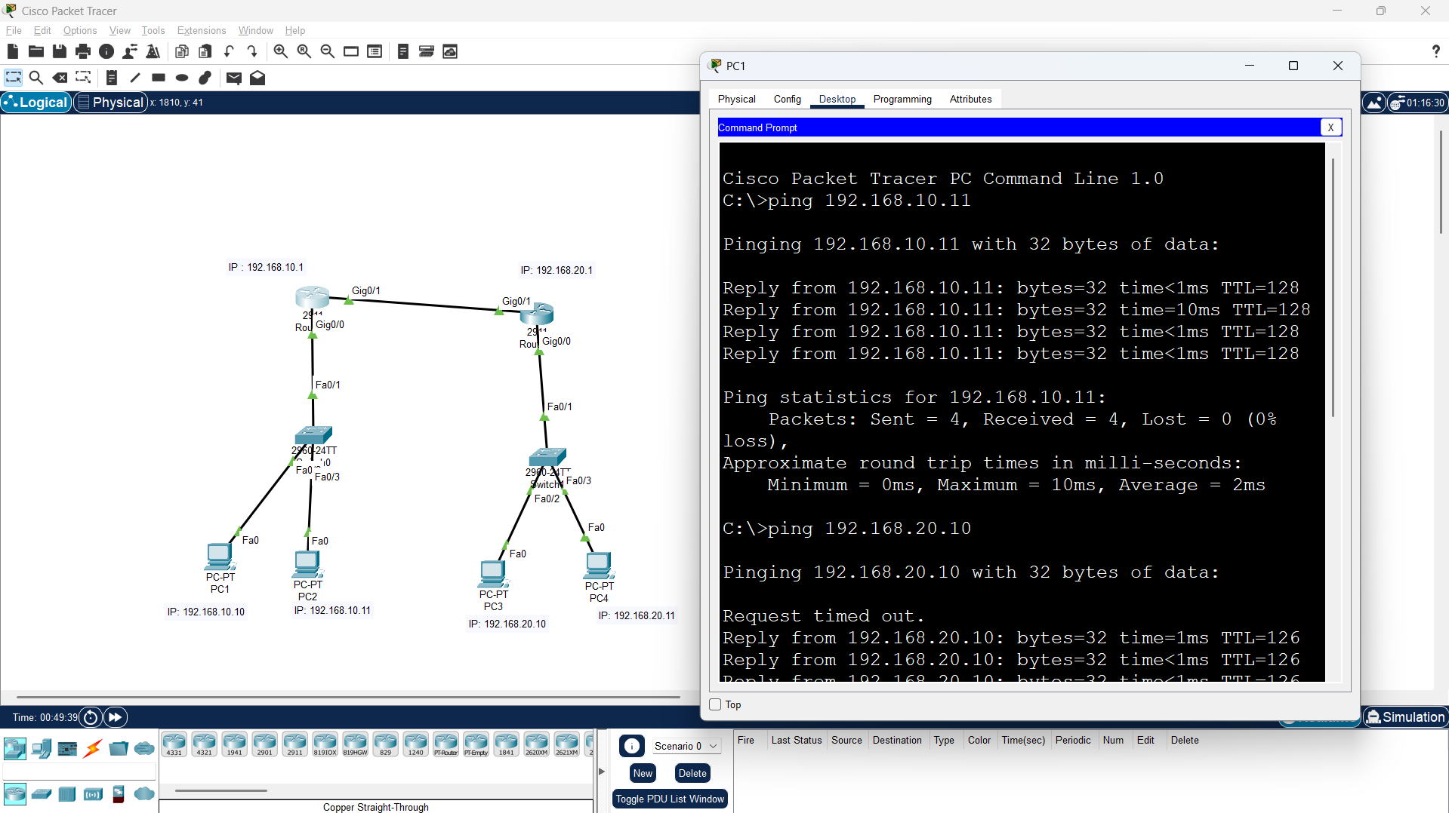
  - For Routing RIP version 2 protocol is being used to connect both the router with each to make a connection with the Copper Straight-Through wire cable to join the devices with each other.

  - Now as the connection is successfully established the ping pc2, pc3 and pc4 is showing the results.

  - The packet flow from the PC1 to PC3 goes in this flow: PC1 → Switch0 → Router0 → Router1 → Switch1 → PC3

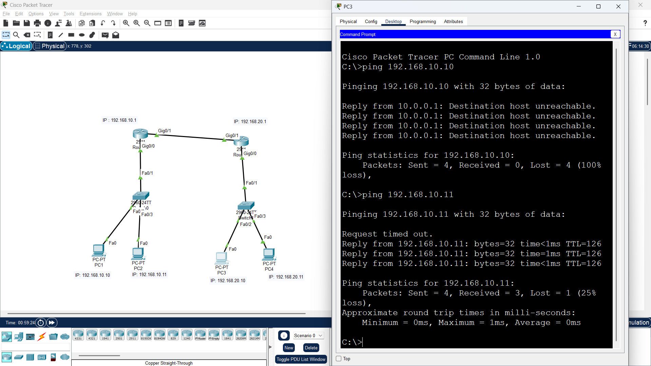
- Implement basic firewall rules and observe their effect.

  - Now From the image, firewall is being Established which is blocking the traffic from PC3 and allowing all the other traffic data coming to PC1.
  - Whenever the traffic is coming from PC3 with the IP address 192.168.10.10 it is showing “Destination unreachable”, instead of which whenever the data is coming from any other ping like 192.168.10.11 it is showing success.
  - It shows that the firewall is being created and is active for the data traffic coming from ping 192.168.10.11 into pc3 is being blocked while for all the other ip addresses it is allowed.

  - So all the 3 tasks are completed.
Task-2 Capture and analyze network traffic using Wireshark
    - Identify different types of traffic, protocols, and their purposes.
  - From the traffic captured, the protocols which were recorded are:
- UDP - User Datagram Protocol - Unreliable, faster transport, used by DNS, streaming, etc.
- TCP - Transmission Control Protocol - Reliable transport, connection-oriented, used by HTTP, HTTPS, FTP, etc.
- ICMPv6 – Used for error reporting, network diagnostics, and various critical functions within IPv6 networks
- TSLv1.2 - Encryption protocols used for HTTPS
- DNS - Domain Name System - Used to translate domain names
- HTTP - Hypertext Transfer Protocol - Used for web traffic
    - Analyze the captured packets to understand how data travels through a network.
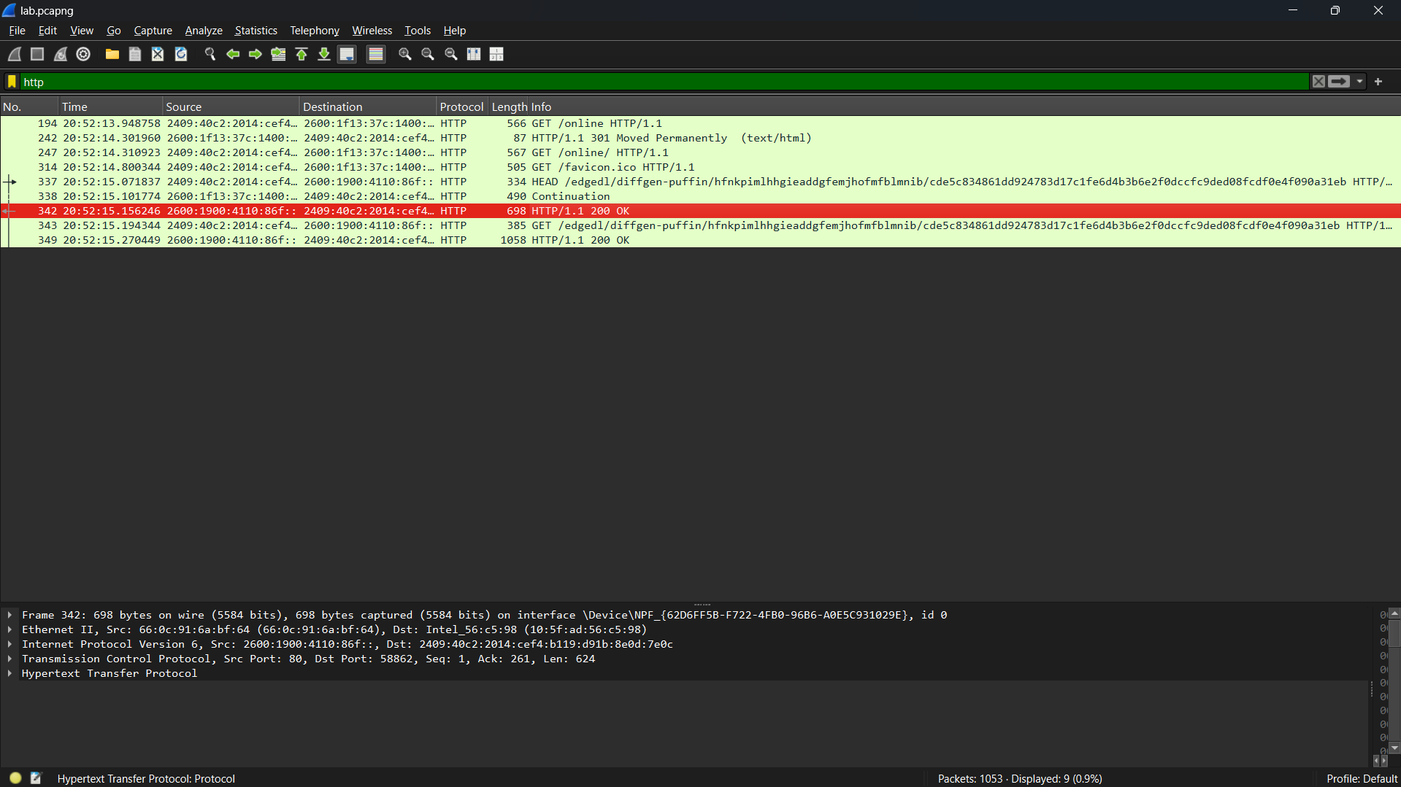
  - Now from the traffic captured, I have applied filter for “HTTP” protocol to capture the traffic of website which is used for http protocol.

  - Here HTTP protocol works on top of TCP and here the request is sent in the form of GET method and the selected section showcase about the successful syn from the server which shows the ‘200 OK’ which states the request and respond in the form 3-way handshake using syn and ack is performed during this communication.

3. Discuss the implications of unsecured protocols and how perimeter devices can help secure them.
- The unsecured protocols are like HTTP or some of TCP also, which send their data packets in the form of plain text which such as:
For HTTP - URLs, headers, and sometimes form data.
For TCP - Follow TCP Stream for HTTP, it literally read the HTML and headers.
  - Attackers can eavesdrop and read sensitive data (passwords, session cookies, URLs). They can perform session hijacking, credential theft, and traffic analysis.
  - Perimeter devices like Firewalls, IDS/IPS, Routers with ACLs, VPN Gateways are used to block and identify such issues.
- Using Wireshark, I observed that protocols like HTTP and FTP transmit data in plaintext, making them vulnerable to eavesdropping. Perimeter devices such as firewalls, routers with ACLs, VPNs, and proxies can mitigate these risks by blocking insecure protocols, enforcing the use of encrypted alternatives (HTTPS, SSH, SFTP), and monitoring traffic for malicious activity.

